To apply for registration - return this form to Bernard Langan:

Bernard Langan
In Motion Center
1091 Calcot Place Suite 412
Oakland, CA 94606

Or by respond by email

blangan@stillnessinmotion.com

Orthopedic Cranial Therapy April 1 - 2, 2017
Registration Form

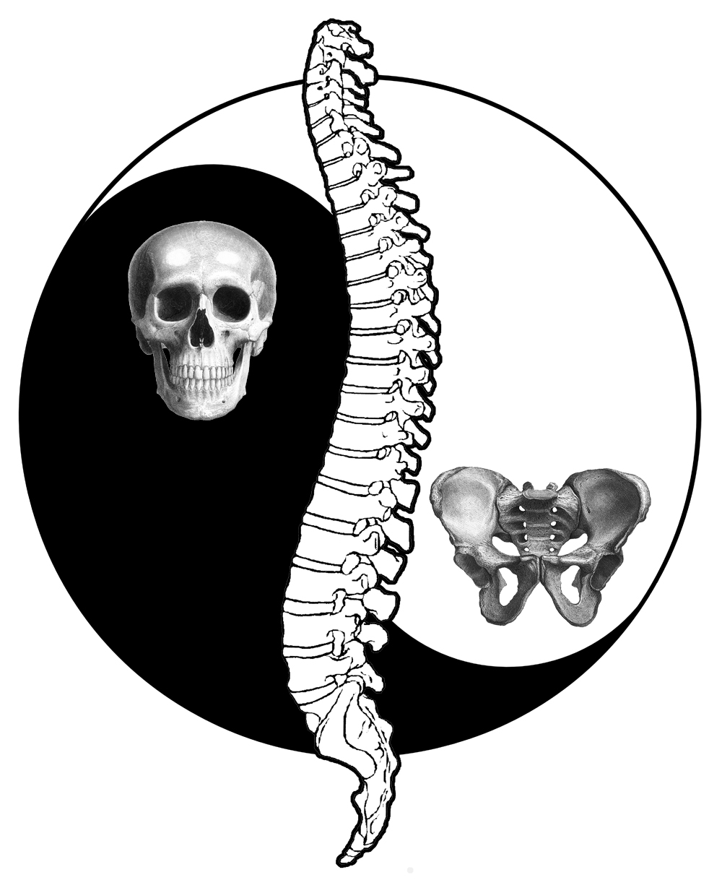

Your Name ________________________________________________________

Phone_____________________________________

Email ________________________________________________________

Occupation _________________________________________

Please check one: Continuing Student ____ New Student ____

Previous Bodywork Experience

Why do you want to take this class ?

I will contact you once I receive your application and it has been approved;
Registration is made through your payment for the seminar

Class will be strictly limited to 18 participants

